SIMATS ENGINEERING
NAME: A.Preetika Sudhakar
RREG NO. 192371073
COURSE NAME: Database Management Systems
COURSE CODE: CSA0501
Ex. No.: 10
AIM: To create view and index on the given relation.

DESCRIPTION:
VIEW:
MySQL has supported database views since version 5+. In MySQL, almost features of views conform to the SQL: 2003 standard. MySQL processes query against the views in two ways:
1.In a first way, MySQL creates a temporary table based on the view definition
2. Statement and executes the incoming query on this temporary table.
3.In a second way, MySQL combines the incoming query with the query defined the view into one query and executes the combined query.
SYNTAX- VIEW:
CREATE [ALGORITHM = {MERGE | TEMPTABLE | UNDEFINED}]
VIEW [database_name].[view_name]
AS [SELECT statement]

SYNTAX- INDEX:
CREATE [UNIQUE|FULLTEXT|SPATIAL] INDEXindex_name
USING [BTREE | HASH | RTREE]
ON table_name (column_name [(length)] [ASC | DESC],...)

Questions on View:
1. Create a view with plot number and price
CREATE VIEW v1 AS SELECT plot_no, price FROM plots;

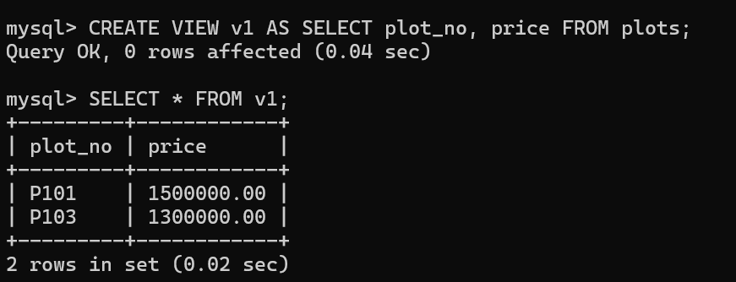

INDEX
1. Create an index on price
CREATE INDEX index1 ON plots(price);
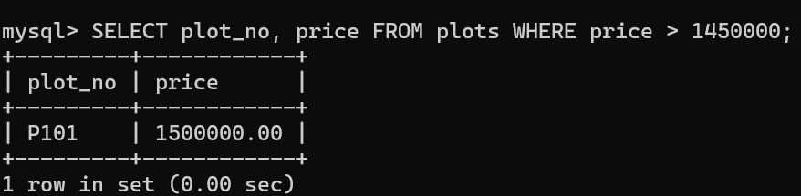

2. Display plot with plot_id = 1
SELECT plot_no, location FROM plots WHERE plot_id = 1;
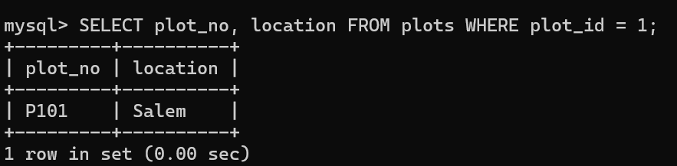

RESULT:
The records from the tables are displayed using view and index on the given relation.

